Introduction to Electronic Circuits

Charity Fischer

Ivy Tech Community College Fort Wayne

Introduction to Electronic Circuits

Circuits are all around the modern world. They help run television remotes, homes, cars, calculators, computers, excavators, and the International Space Station. They’ve become so integral in Americas everyday technology that it’s incredibly difficult to understand how our everyday functions can be accomplished when we look at the basics of circuit design and use. This essay will attempt to illuminate some of the bare science, concepts, purposes, and theories behind what runs the world as it is known today. The basics that will be explained in this essay are voltage, current, resistance, Ohm’s Law, series and parallel circuits, how to evaluate and calculate values in a simple circuit including finding the total power and power dissipation across branched and resistors.

Voltage, in simple terms, is energy as electricity measured in joules per coulomb. In not simple terms it is the pressure of an electrical circuit’s power source and an electric potential in the form of an electric charge imbalance. According to Kuphaldt (2012), “The energy stored there is called *potential energy*, because it has the possibility (potential) of release that has not been fully realized yet” (“Basic Concepts”). Objects can have a positive or negative charge according to its chemical makeup and current condition, the electrons, which have negative charge, want to flow from one object to pone with positive. This micro motion can be seen by the attraction of one object to another, two oppositely charged magnets being one of the more obvious examples. One that many children have practiced, but do not understand is a balloon and hair. When a child rubs a balloon on their hair, this adds more electrons to the balloon giving it more of a negative charge than the wall pulling one to the other. The child may notice that after a time, the balloon will drift down because the balloon has transferred enough electrons to the wall that the imbalance in charge of the balloon and the wall is not enough anymore to hold up the weight of the balloon. This is a simple example of what happens in the balloon. The imbalance of electrons is what causes a current of electricity in a circuit or in static form.

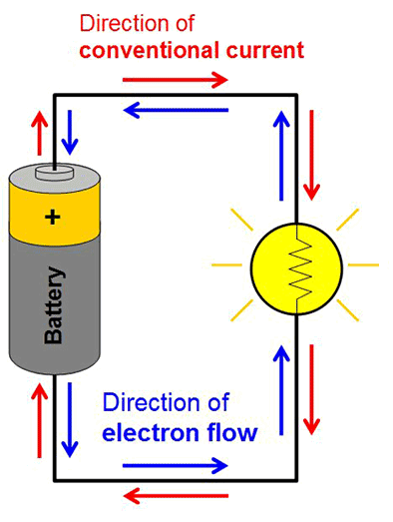The current of a circuit is the rate at which these electrons flow at any particular point and more specifically, the electric charge of the circuit. We know that the electrons are in negatively charged, as they flow from the negative side to the positive side of a power source in an attempt to balance a system, they cause a positive charge in the opposite direction. The unit of current is an ampere. If the circuit is broken and the electrons stop flowing along it, the current will become zero at any particular point. This is much like the flow of heat from one room to another, cold is the absence of heat, though humans often perceive the flow of cold, what they are actually sensing is heat being drawn away by a colder space. When a door is opened from a hot room to a cold room, we can feel the draw of the cold as heat flows away.

The resistance of the circuit is made necessary by this current. The resistance of a circuit will limit the current flow in a circuit. If one connected a battery’s ends with only a single wire, they would find be able to feel the wire become hot because of the increase of the unregulated electrons, but using a resistor creates friction in a way to limit electron movement and balance a circuit. Resistors are often made of metal without many other interesting or extraordinary characteristics and are measured in Ohms which is represented by an upper case Greek letter omega. Resistance is inversely related to current. A “short circuit” is what occurs when there is no resistance and, as described above, becomes hot and potentially dangerous at high voltages. This is potentially dangerous at high voltages necessitating resistors. Resistors come in many different levels of resistance with high variability between them depending on age and usage of the resistor.

These three properties of a circuit; voltage, current, and resistance, are codependent on each other, their relationship is embodied in Ohm’s Law. Ohm’s Law states that voltage (V) is equal to the current (I) multiplied by the resistance (R). Formulated by Georg Simon Ohm (1784-1854) and written as V = I \* R. As the voltage and resistance dictate what the current will be, one can predict or determine the resistance when given the voltage and the current. Likewise, the voltage can be determined when given the resistance and the current. This means that when an electrical professional wants to predetermine the current of the system they need only know which voltage is necessary and then they will be able to solve for the total resistance needed.

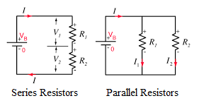There can be more than one resistor in a simple circuit. There are two different ways that these resistors can be places as well. When components are in a series circuit it means that they were placed end-to-end with wires in between. In a series, the current has one path to travel, through each component of the circuit. A parallel circuit is one where components are parallel to each other, where the wire from the battery branches. This gives the current of the circuit multiple paths of flow. In a purely parallel circuit, the total resistance will always be less than the lowest value resistor. Power dissipation in a series circuit is directly related to the value of the total resistance. The highest value resistor will generate the most power in the circuit and the lowest value resistor will generate the lowest power in the circuit. This is inversed in a parallel circuit as the highest value resistor in a circuit will dissipate the lowest power in that circuit. A series circuit may be advantageous if more power is needed on the components, but it can be limiting; if the wire connecting the components and the ends of the power source were to break, the entire circuit would be down. While in a parallel circuit, if one of the branches in the circuit broke the circuit would still function and voltage would remain the same across all branches. A short in a series circuit would cause the current to increase across the circuit while voltage would decrease along the short, but would increase along the rest of the circuit. This would also cause the total power of the circuit to increase. If a short were to occur in a parallel circuit, total Current and power would increase briefly while the voltage would decrease and current along able branches would decrease (Meade, 2007).

Each individual resistor has its value in ohms, but anyone can find the total resistance with a few different formulas and techniques. The way to find total resistance of a series circuit is to add the resistance of each resistor to find the sum; Rt = R1 + R2 + R3 …+ Rn. There are two formulas for adding total resistance in a parallel circuit. The first is the product-over-sum rule; $t=R12=\frac{R1*R2}{R1+R2}$. This can only be used if there are only two resistors that the user is trying to find the total resistance of. The second way to find the resistance of a parallel circuit is called the reciprocal method. It’s the same as adding the reciprocal of each parallel resistor which equals the reciprocal of the total resistance; $\frac{1}{Rt}=\frac{1}{R1}+\frac{1}{R2}+\frac{1}{R3}…+\frac{1}{Rn}$ otherwise written as equal to total resistance; $t=\frac{1}{\frac{1}{R1}+\frac{1}{R2}+\frac{1}{R3}…+\frac{1}{Rn}}$.

Voltage drop is the loss of electric potential across components including, for the purposes of this essay, resistors. When the electric potential of voltage passes through a resistor, it loses some of its energy in the form of heat due to the friction in the resistor. In a series circuit, the voltage drop can be calculated using Ohm’s Law, first, by finding the total current of the circuit using the applied voltage and total resistance. After that, Ohm’s Law will be used again to find the voltage drop across a resistor, for example; if the resistor is R1 the equation to find voltage over R1 is V1 = R1 \* It.

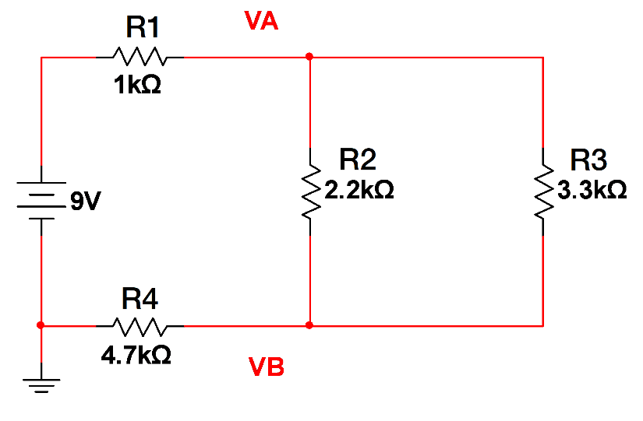Using this working knowledge of a circuit, it is time to build a circuit using a direct current (DC) power source of 9 volts. This circuit will have both series and parallel resistors of different values. A ground is added to the circuit as should be done with all circuits. Grounding in a circuit is used as a safety line for the current of an electrical circuit (Afeword, Dharan, Hanania, Stenhouse, & Donev, 2018). It is essentially a safeguard because it directs any extra current away and protects from surges and possible electric shocks to the user. Note that in this circuit the resistance of each resistor increases as the voltage runs across the wire. This circuit will be used to find the total resistance, the total current, the total power of the circuit, two nodal voltages labeled as VA and VB, branch currents, and the power of those branch currents. All of this can be found when simply given the model, resistor values, and applied voltage values.

To begin in calculating the values along this rather simple circuit, the resistance of the circuit must first be calculated. The resistors can be added using the formulas listed above. When this is done it simplifies the circuit such that when R2 and R3 are added using the product over sum method they become as one resistor in a series. When R2 and R3 are added they are equal to 1.3k ohms, then adding R1, R23, and R4 together gives the total theoretical resistance of 7k ohms. Because the applied voltage and the total resistance are known, the total current and now be calculated using Ohm’s Law. 9 volts divided by 7,000 ohms is equal to 0.0013 amperes.

The power of a circuit can be calculated using three different formulas. $P=I*V$, $P=I*I*R$, and $P=\frac{V*V}{R}$. P here is measured in watts. Using each of these formulas, the total power of the circuit is equal to 0.0115 watts.

Ohm’s Law is used to find the voltage at nodes VA and VB labeled on the circuit above. First, the equation V1 = R1 \* It will be used where V1 is equal to the voltage drop across resistor R1, therefore to find the voltage after R1 the voltage drop must be subtracted from the total applied voltage; VA = V – V1. The voltage drop across the first resistor is equal to 1.282 volts, when this is subtracted from the total applied voltage it can be found that the voltage at VA is 7.718 volts. It is a bit more complicated to calculate a nodal voltage after a branching parallel circuit, but this can still be accomplished by adding R1 and R23 which is the total amount of resistance that voltage has passed through and using this to calculate the voltage drop. When the same process is used at VB as at VA, then VB is found to be equal to 6.026 volts.

The last few steps that will be done here with this circuit is to find the currents in each of the two branches which will then be used to find the power across each branch. For the sake of this, one more formula must be used called the Current Divider Rule. This rule states that I at x is equal to total resistance divided by the resistance at x plus the total resistance, this is then multiplied by the total current. This is otherwise written as $Ix=\frac{Rt}{Rx+Rt}*It$. Because the current is constant in a series circuit, I1 and I2 are the same and the only place where the current is not constant is where the circuit becomes a parallel circuit. The last step in evaluating this circuit is to find the power across each branch. Using the formula P = I \* I \* R, it will be modified slightly to make it for a single branch; P1 = I1 \* I1 \* R1. The circuit’s nodal voltages, branch currents, and power dissipation have now been evaluated in this paper. Note that when the power dissipated at each resistor is added it is equal to the total power.

As complicated as this may seem, it is a very simple circuit and is not to be taken at face value. The last twopages are practice, a drill, to understanding electronic circuits. These are the basics of electronic circuits which should be able to set anyone up to making and testing their own circuits whether by simulation or real world testing using a breadbox and power source. This essay with definitions, formulas, and techniques should give any reader a springboard from which to continue learning. It is a brief overview of the essentials in electric circuits; voltage, current, resistance, power and how to evaluate them in both series and parallel circuits.

References

Afeword, B., Dharan, G., Hanania, J., Stenhouse, K., & Donev, J. (2018). Grounding. In *Energy education*. Retrieved from <https://energyeducation.ca/encyclopedia/Grounding>

Electricity: Electric circuits. (n.d.). Retrieved May 3, 2019 from https://www.physicsclassroom.com/calcpad/circuits

Kuphaldt, T. R. (2012). Basic concepts of electricity. In *Lessons in electric circuits volume 1 direct current*. Retrieved from <https://www.allaboutcircuits.com/textbook/direct-current/chpt-1/voltage-current/>

Kuphaldt, T.R. (2012). Series parallel combination circuits. In *Lessons in electric circuits volume 1 direct current*. Retrieved from <https://www.allaboutcircuits.com/textbook/direct-current/chpt-7/what-is-a-series-parallel-circuit/>

Meade, R.L. (2007). *Comparing series and parallel circuits* [Table]. In *Foundations of electronics: Circuits & devices (conventional flow version)* (p. 147). United States: Cengage Learning.

Meade, R.L. (2007). Ohm’s Law. In *Foundations of electronics: Circuits & devices (conventional flow version)* (pp. 61-79). United States: Cengage Learning.

U.S. Library of Congress. (2017). How does static electricity work? Retrieved from <https://www.loc.gov/rr/scitech/mysteries/static.html>